Mask-Afr-Sierra Leone-Kissi-Pomtan-Seated-Holding vessel

Kissi Pomtan male figure with bared teeth holding a vessel, 7.5 in. tall (19 cm); 3.25 in. wide (8.3 cm); 3.25 in. deep (8.3 cm); ca.12th century CE to 19th century CE.

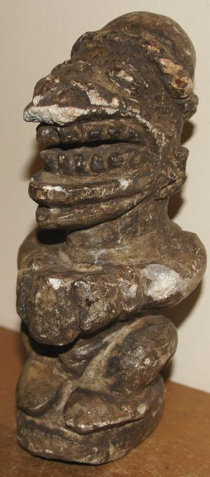 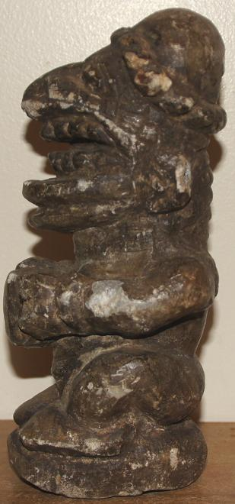

This rare ancestral figure is of the **Kissi people**, an ethnic group living in Guinea, Sierra Leone and Liberia. The Kissi language is of the Niger–Congo family. They are well known for basketry, weaving on vertical looms, and iron working from rich deposits of iron. In the late nineteenth and early twentieth centuries the Kissi smiths produced the famous "Kissi penny", an iron money that was used widely in West and even Central Africa.

This enigmatic *pomdo* (plur. *pomtan* ) soapstone figure of French Guinée with a rather large head, bulging eyes, flat nose and filed teeth probably represents an ancestral spirit of the shadowy and little-understood ancestors of the modern Kissi groups of modern Sierra Leone. Excavated from fields around the modern Kissi territory by the Kissi themselves, these figures are revered as ancestors, put in communal shrines and in private houses, where they receive libations in the hope they would attract good harvests or promote health. This figure is holding a cup.

The original function and age of these pieces, which are disinterred by local farmers plowing fields, remain unknown. Some, like this one with a dark patina from centuries of having been buried, appear to predate the arrival of the Portuguese in the Gulf of Guinea in the sixteenth century. As the *pomtan* are typically not in their original location, little is known of their taphonomy, associated artifacts, the instruments used to carve them or the context of their intended use. Despite these unknowns, whenever they are recovered they are revered as ancestral spirits. The *pomdo* (plur. *pomtan* ), as they are called by the Kissi and the Mende, are figures like this one with crested hairstyles, bulging eyes, squat postures and filed teeth. The more ornate *pomtan* probably represent chiefly spirits as this one with an ornate headdress and in a seated position, while less ornate *pomtan* which are not seated probably represent ancestral spirits. Since there was no major population replacement in the Kissi population area, the ancient cultures of this area were probably ancestral to modern Kissi groups. In fact, parallels can be drawn between the archaeological and modern cultures. The modern Kissi are animistic and have talismans to protect them from the spirits, especially witches. Their treatment of these *pomtan* reflects this animism. So it is possible that these *pomtan* are in fact being used much in the same way that they were intended to be. This is a fascinating and well-carved piece of ancient African art.

| Shipping details |
| --- |
| **Ralph J Coffman Jr**  149 Atlantic Ave  Swampscott MA 01907-2427  United States |

## Order details

|  |  |  |  |  |  |  |  |
| --- | --- | --- | --- | --- | --- | --- | --- |
|  | **Item title** | | **Available actions** | | **Shipping & handling (estimated delivery*)** | | **Price** |
| Seller: | | [**Member id** jeanpier_360](http://myworld.ebay.com/jeanpier_360) ( [**Feedback Score Of** 0](http://feedback.ebay.com/ws/eBayISAPI.dll?ViewFeedback&userid=jeanpier_360) ) | | [Contact seller](http://contact.ebay.com/ws/eBayISAPI.dll?ShowCoreAskSellerQuestion&frm=3998&iid=261117178148&redirect=0&requested=jeanpier_360) | |  | |

|  |
| --- |
| Paid on Oct-29-12 via PayPal |

[BEAUTIFUL GROUP OF THREE (3) STONE OLD SCULPTURES FROM WEST AFRICA**- opens in a new window or tab**](http://cgi.ebay.com/ws/eBayISAPI.dll?ViewItem&item=400331287007)

**Item Id:**400331287007 - Price: US $150.00

Quantity:1

Having a problem with this purchase? [We can help](javascript:;)

|  |
| --- |
|  |
| |  |  | | --- | --- | | [Leave feedback](http://feedback.ebay.com/ws/eBayISAPI.dll?LeaveFeedbackShow&useridfrom=802-867&useridto=wigder-newyork&item=400331287007&transactid=0) |  | |

Shipped with item above

US $150.00